JavaEE - XML

Intro
XML is an industry standard defined by the World Wide Web Consortium (W3C).
The eXtensible Markup Language (XML), derived from the Standard Generalized Markup Language (SGML), was originally envisioned as a language for defining new document formats for the World Wide Web. XML can actually be considered to be a meta-language as it is used to construct other languages.

XSD (XML Schema Definition) = grammar for xml documents.

DTD (Document Type Definition) = first language definition mechanism replaced by XSD.

XSD = Xml Schema Definition is an XML-based grammar declaration used to describe the structure and content of an XML document.
Thanks to XSD, elements and attributes become strongly and have datatype information associated with them. Such strongly typed XML can now be mapped to objects using JAXB.

XSD Elements and Attributes
- schema Is the root element of every XML Schema. It may contain some attributes such as the schema version
- xmlns Each element in the schema has a default prefix xs: (or sometimes xsd: although any prefix can be used) which is associated with the XML Schema namespace (xmlsn) through the declaration, xmlns:xsd="http://www.w3.org/2001/XMLSchema"
- element Elements are declared using the element element. For example, order is defined as an element and appears as <order id="1234" date="11/08/2013" total_amount="93.48"> in the XML document
- type An element can be of a simple type such as string, decimal, long, double and so on (type="xs:long") or a complex type (type="customer")
- minOccurs, maxOccurs Define the minimum and maximum occurrence of a type. This value may be a positive integer or the term unbounded to indicate there is no maximum number of occurrences
- complexType It describes a complex type with elements, sub-elements, and attributes. A complexType element can contain another complexType. For example, the complex type order contains a complexType
- sequence An element may include other elements, which are called child elements. The sequence element specifies that the child elements must appear in a sequence. Each child element can occur from 0 to any number of times
- attribute A complex type may have one or more attributes that are defined by attribute elements. The orderLine type has two attributes; item and quantity
- choice Used to indicate only one set of elements can be present in the containing element
- complexContent A complex type can extend or restrict another complex type using complexContent element
- extension The extension element extends an existing simpleType or complexType element

SAX = Simple API for XML (SAX): reads in the XML data source and makes callbacks to the application whenever it encounters a distinct section (the end of an element).

DOM = Document Object Model (DOM): reads in an entire XML data source and contructs a treelike representation of it in memory.

XPath = is a query language designed to query XML structures that is used by a variety of other XML standards, including XSLT, XPointer and XQuery. It defines the syntax for creating expressions, which are evaluated against an XML document.
The most common type of XPath expression is a location path, which represents a node.

XQuery = is another query language that is designed to query collections of XML data using XPath expressions.

XSLT = A key advantage of XML over other data formats is the ability to transform an XML document from one vocabulary to another, in a generic manner. For example you can render an XML document into a print-friendly format or into a web page. The technology that enables this translation is the eXtensible Stylesheet Language Transformations (XSLT).
Simply stated, XSLT provides a framework for transforming the structure of an XML document by combining it with an XSL stylesheet to produce an output document.

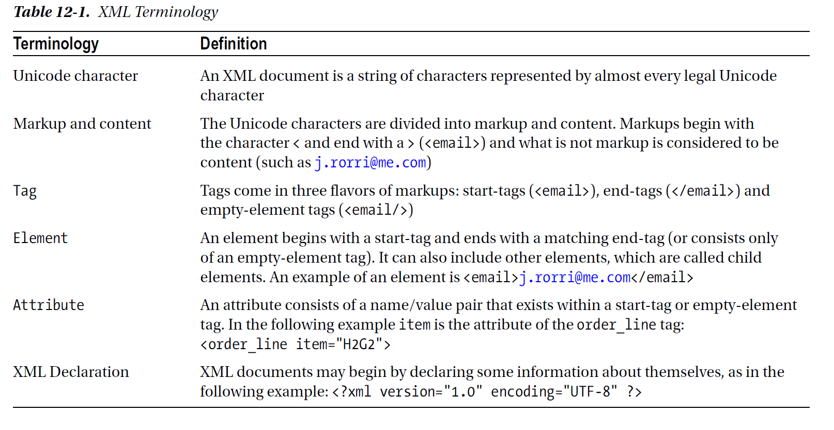

XML Specifications in Java
The XML ecosystem was created by the W3C. But because it works hand in hand with Java, there are several XML-related specifications that were created within the JCP. Examples include from processing XML to binding documents into Java objects.

JAXP (Java Architecture for XML Processing) is a low-level specification that gives you the possibility to process XML in a very flexible manner; allowing you to use SAX, DOM, or XSLT. It is the API used under the hood for JAXB or StAX.

JAXB (Java architecture for XML Binding) specification provides a set of APIs and annotations for representing XML documents as Java artifacts, allowing developers to work with Java objects representing XML documents. JAXB facilitates unmarshalling XML documents into objects and marshalling objects back into XML documents. Even if JAXB can be used for any XML purpose, it is tightly integrated with JAX-WS.

StAX (Streaming API for XML) is an API to read and write XML documents. Its main focus is to gather the benefits of tree-based APIs (DOM parsers) and event-based APIs (SAX parsers). DOM parsers allow random, unlimited access to the document, while SAX parsers provide a smaller memory footprint and have reduced processor requirements.

JAXP with SAX
SAX is known for its low memory requirements and fast processing functionality. SAX is an event-driven, serial access mechanism to parse XML documents. You have to provide the parser with callback methods that are invoked by the parser as it reads the XML document. For example, the SAX parser calls a method in your application each time an element is reached and calls a different method when a text node is encountered.
The way in which you process the current element in an XML document without maintaining any state from previously parsed elements is called state-indipendente processing. This is the most suited model for processing XML resources with SAX parsers. The other model is state-dependent parsing, which is handled with pull parsars like StAX parsers.

Difference beetween Specification and Reference Implementation
The primary goal of a Reference Implementation (RI) is to support the development of the specification and to validate it. Example Metro is a production-quality implementation of JAXB (inside JavaSE!!!). The RI for the JAXP specification is integrated into Java SE. StAX RI is the reference implementation for the JSR-173 specification.

Metro has the schema compiler (xjc) and the schema generator (schemaGen). While marshalling/unmarshalling deals with objects and XML documents, the schema compiler and the schema generator deal with classes and XML Schemas.

OXM (Object/XML Mapping or O/X Mapping)
oxm is the act of converting an XML document to and from an object. This conversion process is also known as XML Marshalling, or XML Serialization.

JAXB
The Java Architecture for XML Binding (JAXB) specification (JSR 222) provides a higher level of abstraction than SAX or DOM and is based on annotation. JAXB defines a standard to bind Java representation to XML and vice versa. This allows developers to work with Java objects that represent XML documents.
The center of the JAXB API is the javax.xml.bind.JAXBContext class.

Basic annotation si @javax.xml.bind.annotation.XmlRootElement.

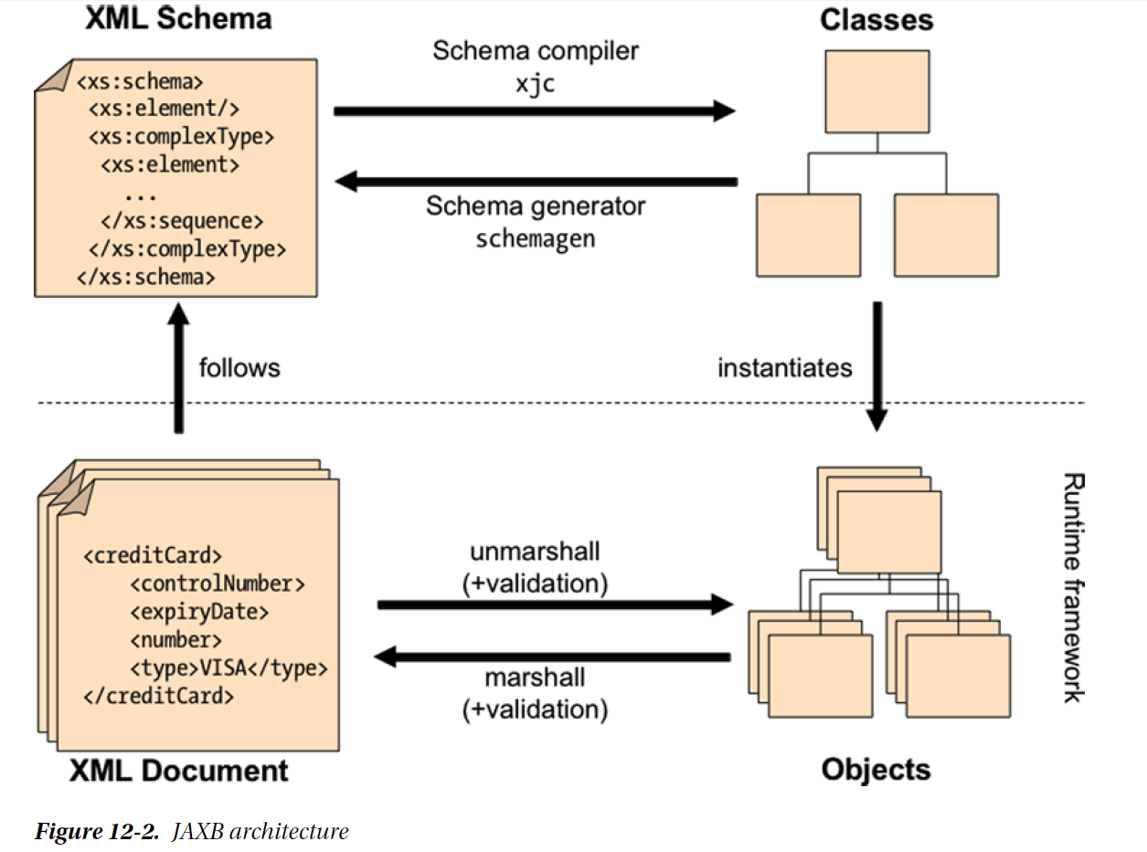

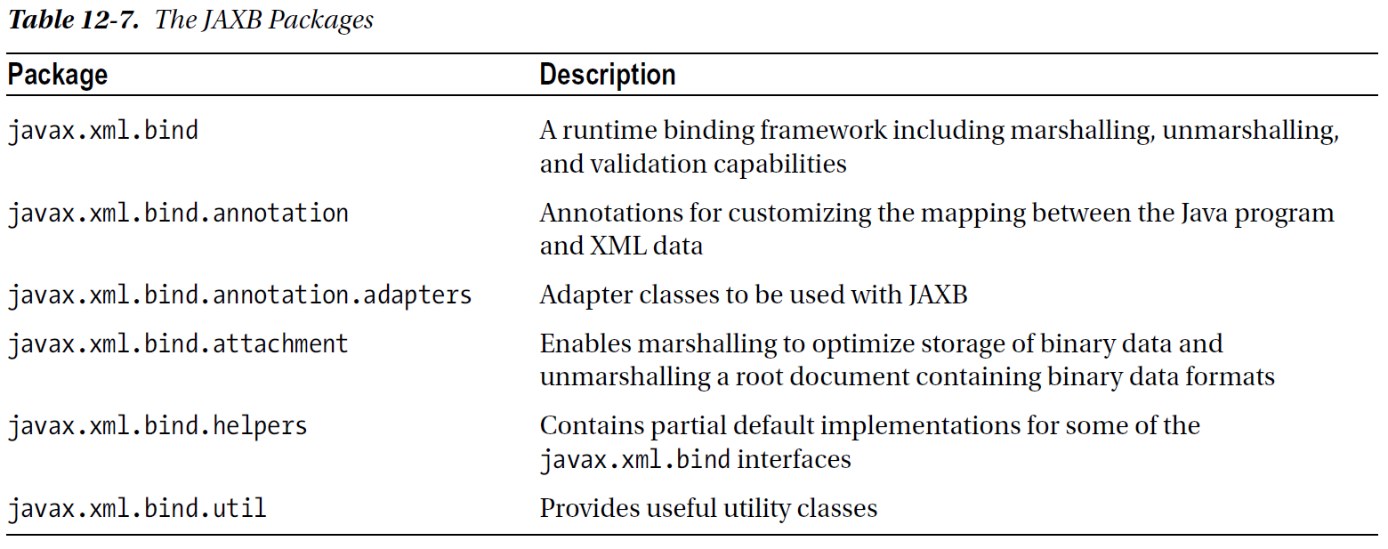

JAXB Annotations
JAXB is similar to JPA in many ways. However, instead of mapping objects to a database, JAXB does the mapping to an XML document. Also, like JPA, JAXB defines a set of annotations (in the javax.xml.bind.annotation package) to customize this mapping, and relies on configuration by exception to minimize the work of the developer. If persistent objects have to be annotated with @Entity, the correspondent in JAXB is @XmlRootElement.

JAXB Annotations list
- @XmlAccessorType Controls whether attributes or getters should be mapped (FIELD, NONE, PROPERTY, PUBLIC_MEMBER)
- @XmlAttribute Maps an attribute or a getter to an XML attribute of simple type (String, Boolean, Integer, and so on)
- @XmlElement Maps a nonstatic and nontransient attribute or getter to an XML element
- @XmlElements Acts as a container for multiple @XmlElement annotations
- @XmlEnum Maps an enum to an XML representation
- @XmlEnumValue Identifies an enumerated constant
- @XmlID Identifies the key field of an XML element (of type String), which can be used when referring back to an element using the @XmlIDREF annotation (XML Schema ID and IDREF concepts)
- @XmlIDREF Maps a property to an XML IDREF in the schema
- @XmlList Maps a property to a list
- @XmlMimeType Identifies a textual representation of the MIME type for a property
- @XmlNs Identifies an XML namespace
- @XmlRootElement Represents an annotation required by any class that is to be bound as the root XML element
- @XmlSchema Maps a package name to an XML namespace
- @XmlTransient Informs JAXB not to bind an attribute (analogous to the Java transient keyword or
- @Transient annotation in JPA)
- @XmlType Annotates a class as being a complex type in XML Schema
- @XmlValue Allows the mapping of a class to a simple schema content or type

Reference

Books
[1] - [2013] Beginning Java EE 7

Links
http://www.liquid-technologies.com/Tutorials/XmlSchemas/XsdTutorial_04.aspx

